**Smart Warehouse (IoT)**

**Capstone Project Proposal**

**Submitted by:**

**101903543 Aditya Kumar**

**101903625 Rohan**

**101903514 Saarthak Bhatia**

**101903541 Vatsal Kumar**

**BE Third Year- COE**

**CPG No. 151**

Under the Mentorship of

Dr. Rajkumar Tekchandani

Assistant professor



**Computer Science and Engineering Department**

**Thapar Institute of Engineering and Technology, Patiala**

**March (2022)**

**TABLE OF CONTENTS**

* Mentor Consent Form <3>
* Project Overview <4>
* Problem Statement …..
* Need Analysis (1 Page) …..
* Literature Survey (3 Pages) …..
* Objectives
* Methodology
* Project Outcomes & Individual Roles
* Work Plan
* Course Subjects
* References

**Mentor Consent Form**

I hereby agree to be the mentor of the following Capstone Project Team

| **Project Title:** | | |
| --- | --- | --- |
| **Roll No** | **Name** | **Signatures** |
| 101903543 | Aditya Kumar |  |
| 101903625 | Rohan |  |
| 101903514 | Saarthak Bhatia |  |
| 101903541 | Vatsal Kumar |  |

NAME of Mentor: Dr. Rajkumar Tekchandani

SIGNATURE of Mentor: .**** . . . . . . . . . . . . . . . . . . . . . . . . . . . . . . . . . . .

**Project Overview**

* Truly meaningful reform of India’s agricultural sector will require a comprehensive package of measures, to address not just how food is sold but also the entire supply chain, from production to processing to distribution. Solutions must balance multiple interests: food security for the nation, fair returns for producers, growth prospects for the private sector, and the creation of new employment opportunities in rural India.We are determined to create a system for counting the number of sacks entered into the warehouse and count them. We would be creating a working model to count the number of sacks which are stored in the warehouse and would be updating it to the database and these changes would be reflected in the application.
* Indian agriculture is not an exception for this, now India is facing two main problems concerning agriculture. India tried to be self-sufficient in agriculture through the five year plans. After independence by taking systematic efforts due to their unique importance, agriculture gets more and more attention in every five year plan and top priority is given for the development of agriculture in our Country.
* India is experiencing a high rate of economic growth in the last two decades but the growth has been coupled with high rate of food price inflation. The growth has been very uneven across sectors with agriculture remaining very sluggish. The increase in per capita income has significantly increased the demand for food but agricultural production has failed to keep pace with the growing demand. . There is no long run relationship between money supply and agricultural price. Increasing public expenditure and unfavorable foreign exchange rate have some effects on price although the results are not robust.
* Here we tried to make a project to help farmers as well as normal households here we are trying to create transparency between the government and farmers moreover normal households. This project will help the farmers to get the right price for the crops they have sown and reaped. For households this project will be telling the availability of the crops ,hence this will be creating transparency for the farmer ,government and households. We will be trying to make a warehouse in which we would be trying to calculate the weight using sensors so that we can sense the weight set for a sack. We store information for particular workers holding their weight and other details and therefore adding the weight of a sack to its weight would be counted as In this project we can prevent a rise in the price of grain or other edible items during times of inflation. This would be a great help for farmers and the public and we will connect this via app or website so that there is transparency and can later be shared with other peoples.
* India needs this type of technology because the consumption for the food is very high so high demands lead to high rates and thus the prices will shoot up and poor people won't be able to eat. The death rate because of food is increasing year by year and countries with the most population suffer the most.

**Need Analysis**

* India largely depends on the agriculture sector. Besides, agriculture is not just a means of livelihood but a way of living life in India. Moreover, the government is continuously making efforts to develop this sector as the whole nation depends on it for food. But some of the brokers which are government appointed i.e., government market where farmers sell their crops at a certain MSP(minimum selling price).
* The payment of the crops is sanctioned after sometime between that time those officials try to keep some part of the crop in some other warehouse or reservoirs and when time of payment comes they keep telling innocent farmers that their crops have been destroyed by bad weather or some insects. So due to this they keep their reserves full. When the time of some mishappening comes i.e., better known as inflation comes they sell those crops or edible items at higher prices. Snatching the livelihood of hardworking and innocent farmers and earning profits from the normal households this condition is called inflation.
* Inflation is the decline in purchasing power of a given currency over time. A quantitative estimate of the rate at which the decline in purchasing power occurs can be reflected in the increase of an average price level of a basket of selected goods and services in an economy over some period of time. The rise in the general level of prices, often expressed as a percentage, means that a unit of currency effectively buys less than it did in prior periods.
* This project presents a proposed model for Smart Agriculture to develop a real time monitoring system for counting the number of sacks of crops stored in the warehouse. It will also be possible to control various operations of the field remotely from anywhere, anytime by mobile as well as web application. The IOT based agricultural monitoring system has been used to maximize the profit for farmers and the public,also creating transparency for removing inflation which creates problems. for all yields of crops by monitoring the count of sacks and thus providing the required information to farmers as well as to the whole nation remotely. This system can be implemented in any type of warehouse used for food storages. The use of IOT over the other technology one aides in deploying it in any type of environment for monitoring, making it flexible.
* This system will tell us about the number of sacks stored in the warehouse of the location and sharing of the data with all. For instance we will open this app and will get the data we desire to see, that is the number of sacks stored and when it was stored. So there would be no inflation situation and we are providing transparency. So this project will be helping in analyzing the total food available in the country and adequate pricing for the food so that richer as well as poor people can afford as food is the basic need for the living and no one should be deprived of it.

**Literature Survey**

The problem of wastage of food grains in a country like India where 22 percent of Indians fall below the official poverty line is nothing but criminal. Even with less than 60% crop yield, the storage capacity in the country is woefully short. As in June 2011, FCI was holding 65.5 million MT of wheat and rice against the buffer and strategic norms of 31.94 million MT of food grains. This is against the backdrop of an increased production of principal food grains to 263.2 million MT in 2013-14, an increase of 23.5% during the decade. With increased procurement of food grains by Food Corporation of India (FCI), the principal agency entrusted with the task of feeding the millions of Indians, the storage losses also have increased. The losses are due to both non-availability of covered storage facilities with the agencies and also due to poor management of available storage at the farm level and the organized storage levels. The post-harvest losses in India amount to 12 to 16 million metric tons of food grains each year, an amount that the World Bank stipulates could feed one-third of India's poor. The monetary value of these losses amounts to more than Rs.50,000Cr per year(Singh, 2010).Ramesh (1999) reported that high wastage and value loss are due to lack of storage infrastructure at the farm level. As per estimates available, the storage gap in warehousing capacity in the next 5 to 10 years is around 35 million MT. There is therefore a need for not only sufficient modern warehousing capacity but also ensuring scientific storage methodology to be followed in the storage facilities existing.

**1.** **AGRICULTURAL WAREHOUSE MANAGEMENT SYSTEM**

**Brisin B Krishnan, Jain V John, Kishore S, Mahantesh S and Prof. Savita C H. explains aboutAGRICULTURAL WAREHOUSE MANAGEMENT SYSTEM.** It deals with the proper usage of agricultural warehouse facilities and implementing new ways to increase the shelf life of agricultural produce leading to better financial stability to farmers who currently have lots of problems during cultivation.

**2.** **DEVELOPMENT OF LEAKAGE DETECTION SYSTEM**

**Sahil Adsul, Ashok Kumar Sharma and R. G. Mevekari explains about DEVELOPMENT OF LEAKAGE DETECTION SYSTEM.** Leakage in a system makes resource losses occur at thermal power plants, water distribution systems, overhead tanks, boilers etc. Leakage can occur due to aging infrastructure and environmental conditions, which should be detected. Due to these losses it is required to develop a system which can detect leakage in water, gas, oil etc. This paper presents a wireless leakage detection system using various sensors and microcontrollers which makes system portable and Non-Destructive techniques (NDT). In this system the parameters like humidity, temperature, pressure, sound detection and gas detection around leakage areas are detected using sensors and an arduino microcontroller. The sensed data is acquired and transmitted via ZigBee and processed over GUI developed in LabVIEW transferred to a webpage.

**3.** **PC based Weight Scale System With Load Cell for Product Inspection**

**Anton Satria Prabuwono, Halibullah Akbar and Wendi Usino explain about PC based Weight Scale System With Load Cell for Product Inspection.** Personal computer (PC) based weight scale system is a digital measurement system for checking the weight of a product in the manufacturing process. The system will connect directly to the measurement device and will display the result automatically. The load cell has been applied as a measurement sensor. The interface allows users to interact with the system. A software user interface along with the signal conditioning and data acquisition hardware has been fabricated. The system has been successfully tested to obtain various load measurements. A few suggestions have also been drawn up for the improvement of the system. As the system is easily customizable, its seamless integration is always possible in a highly automated industry. Thus, there is a great potential for this system to be used in numerous industries, where load measurement form is a part of the manufacturing process.

**4. ANALYSIS AND STUDY OF WAREHOUSE MANAGEMENT SYSTEMS**

**Divyendu briefs us on ANALYSIS AND STUDY OF WAREHOUSE MANAGEMENT SYSTEMS.** Inside the walls of the warehouse, the utilization of every component—space, people, inventory and equipment—will impact the bottom line in profound ways over time. Warehouse Management enables us to analyze these components continually, so we can conserve effort, fill orders faster and more accurately, save space and reduce inventory. In this paper, a preliminary simplified layout of a warehouse using the quantities and sales data obtained from two frontrunners in shoe manufacturing is designed. The data has been analyzed and arranged in terms of the volumetric distribution of the goods, using extensive analysis through pivot tables, pie charts, tables and bar graphs. The proposed layout for the warehouse has been provided towards the end. The paper considers various theoretical considerations to keep in mind before designing a warehouse. It also looks at the need for warehousing, the functions performed by warehousing, and the principles required for designing the layout of a warehouse, with due considerations of the material handling principles for material movement inside the warehouse. In the second part of the analysis, simple linear regression models are utilized to analyze and organize data for effective determination of the future demand trends in the shoe manufacturing industry and determine the future scope of expansion for demand adjustment. In the final part of the analysis, inventory management policies are utilized, both Continuous Review Policy and Periodic Review Policy, to determine the average inventory level requirements for the warehouse. Finally, the Review Policy most suitable for each product line is determined.

**5.**  **A Complete Guide to Agricultural Product Processing and Storage**

**Here M. S. Adiaha in his Complete Guide to Agricultural Product Processing and Storage explains us about.** In fighting the global food crisis, Agricultural product processing and storage plays an important role in food and feed preservation for the continual survival of man. Through the development of modern storage facilities, food crop preservation becomes easy and simple to follow. Rice and oil palm are a selected few agricultural products that will be taken into consideration in the course of this work. The study was conducted in Obubra Local Government Area of Cross River State, Nigeria, Storage experimentations were done at the Faculty of Agriculture and Forestry Multipurpose screen house. The study was conducted with the aim to look into processing procedures and find possible solutions to the problems facing the farmers and agricultural machine operators in Agric business. Low level of mechanization was observed to be high in areas visited during the period of this research.

**After the literature review and an initial study on agricultural storage practices in India, it can be concluded that this agriculture warehouse management system would help farmers save their produce in a more economical and feasible manner. This system can be implemented on existing warehouses. It also helps in curbing down the grain or food shortage problems faced by the nation. If this system is implemented on a nationwide scale India would become the top agricultural exporter in the world. Warehouse performance indicators should be introduced to check the efficiency of the warehouses which should include quality parameters such as ability to control wastage, pest control measures, provide a wide range of testing, grading and certification services which can help in ascertaining the value of the commodity deposited and bring transparency among all interested entities.**

**Objectives**

* Through this Project we aim to provide the Country with a way to use its available agricultural resources to a greater percent than as of now.
* While doing so also try to the process Transparent
* And provide Nation with accurate data of stocks(Storared Agriculture Products) Stored Throughout the nation which may enable us in damping the food crisis faced by citizens.
* And Helping Farmers to get reasonable costs for their hard work.

**Methodology**

* We plan to use Principles of Web dev,AI, Machine Learning, Microcontrollers and Sensors.
* For developing A workable Warehouse we use a combination of sensors and microcontrollers to have been able to trace, detect and load weight and the goods.
* And a website is made to present data in layman's terms.
* And an online cloud database is maintained to store data taken for various warehouses.
* 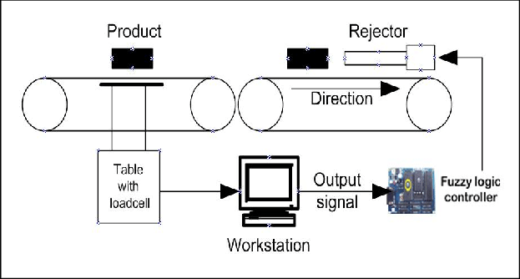

**Work Plan**

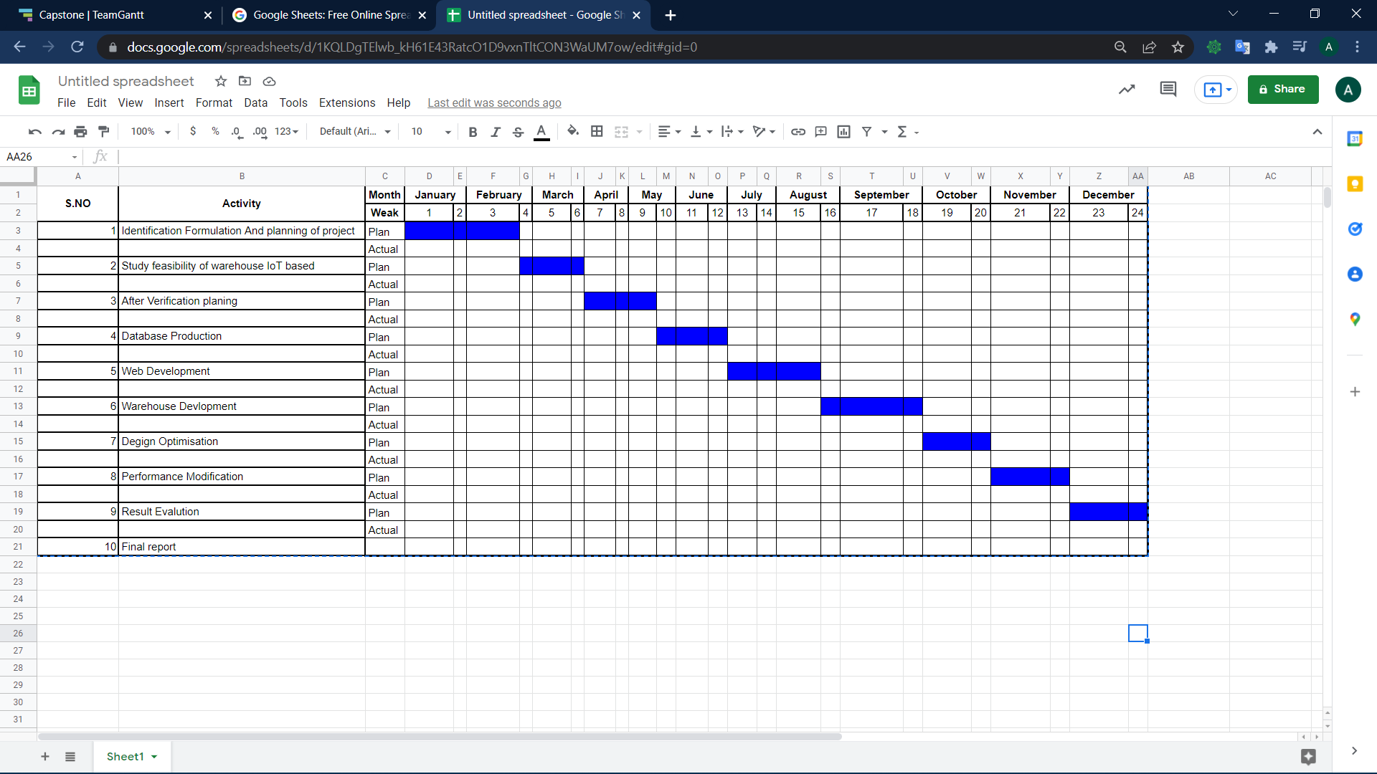

**Project Outcomes & Individual Roles**

* A website which is used to display Data in Laymans and easy to understand Terms.
* A prototype of Smart warehouse which helps us in all the data collection.
* This project can enable us by helping in Cost management and waste reduction thanks to the increased control over the goods.
* Increased business efficiency through process automation. By using smart devices, you can automate multiple processes across your storage cycle, e.g. tracing, Storing, or pest control.
* Enhanced product quality and volumes. Achieve better control over the storage process and maintain higher standards of crop quality and quantity through automation.
* Optimizing floor level activities in warehouses and distribution centers.
* Enabling the best layout and configuration for the warehouse.
* Enhancing the efficiency of warehouse equipment.
* Providing unparalleled global visibility in the supply chain.
* Empowering managers to manage stock levels.

| Name | Roll No. | Role |
| --- | --- | --- |
| Aditya Kumar(Group Leader) | 101903543 | Web Dev and R&D |
| Rohan | 1010903625 | Js,django,Arduino |
| Saarthak Bhatia | 101903514 | Flutter, Python |
|  |  |  |

**Course Subjects**

* Although, it covers the whole course curriculum of B.E. Computer Engineering by gaining little knowledge from each course and using it in real life projects. But the major subjects that are relevant are:

| **S.No** | **Subject** | **Subject Code** |
| --- | --- | --- |
| 1 | Electronic Engineering | UEC001 |
| 2 | Microprocessors based system design | UCS617 |
| 3 | Database Management System | UCS310 |
| 4 | Software Engineering | UCS503 |
| 5 | Machine Learning | UML501 |
| 6 | Embedded system design | UCS704 |
| 7 | Manufacturing processes | UTA002 |

**References**

1. Anand, K.; Jayakumar, C.; Muthu, M.; Amirneni, S. Automatic Drip Irrigation System using Fuzzy Logic and Mobile Technology. In Proceedings of the IEEE Conference on Technological Innovations in ICT for Agriculture and Rural Development, Chennai, India, 10–12 July 2015.
2. Mathivanan, S.; Jayagopal, P. A Big Data Virtualization Role in Agriculture: A Comprehensive Review. Walailak J. Sci. Tech. 2018, 16, 55–70. [CrossRef]
3. Xie, N.; Zhang, X.; Sun, W.; Hao, X. Research on big data technology-based agricultural information system. In Proceedings of the International Conference on Computer Information Systems and Industrial Applications, Bangkok, Thailand, June 2015; pp. 388–390
4. Dela Cruz, J.R.; Baldovino, R.G.; Bandala, A.A.; Dadios, E.P. Water Usage Optimization of Smart Farm Automated Irrigation System Using Artificial Neural Network. In Proceedings of the Fifth International Conference on Information and Communication Technology (ICoICT), Melaka, Malaysia, 17–19 May 2017.
5. . Murdyantoro, E.; Nugraha, A.W.W.; Wardhana, A.W.; Fadli, A.; Zulfa, M.I. A review of LORA technology and its potential use for rural development in Indonesia. In AIP Conference Proceedings; AIP Publishing LLC: Melville, NY, USA, 2019; Volume 2094, p. 020011.
6. Anand, K.; Jayakumar, C.; Muthu, M.; Amirneni, S. Automatic Drip Irrigation System using Fuzzy Logic and Mobile Technology. In Proceedings of the IEEE Conference on Technological Innovations in ICT for Agriculture and Rural Development, Chennai, India, 10–12 July 2015
7. Chandrappa, V.Y.; Ray, B.; Ashwath, N.; Shrestha, P. Application of Internet of Things (IoT) to develop a smart watering system for cairns parklands—A case study. In Proceedings of the 2020 IEEE Region 10 Symposium (TENSYMP), Dhaka, Bangladesh, 5–7 June 2020; pp. 1118–1122.
8. Bacco, M.; Berton, A.; Ferro, E.; Gennaro, C.; Gotta, A.; Matteoli, S.; Paonessa, F.; Ruggeri, M.; Virone, G.; Zanella, A. Smart farming: Opportunities challenges and technology enablers. In Proceedings of the 2018 IoT Vertical and Topical Summit on Agriculture-Tuscany (IOT Tuscany), Tuscany, Italy, 8–9 May 2018; pp. 1–6